**CHAP 6: END OF WORLD WAR 2 IN EUROPE AND ASIA PACIFIC.**

|  |
| --- |
| **WHAT YOU SHOULD KNOW IN THIS CHAPTER**   1. STRENGTH OF THE ALLIES    1. AMERICAN ENTRY INTO THE WAR (ECONOMIC RESOURCES AND MANPOWER)    2. ALLIED STRATEGIES (D-DAY, ISLAND HOPPING, DROPPING OF ATOMIC BOMB)    3. ROLE OF THE SOVIET UNION. 2. MILITARY WEAKNESSES OF GERMANY AND JAPAN.   GERMANY   * 1. INEFFECTIVE COMMAND STRUCTURE   2. WAR ON TWO FRONTS   JAPAN   * OVEREXTENSION OF EMPIRE * INABILITY TO ACCESS RAW MATERIALS FROM EMPIRE   STUDENTS MUST BE AWARE OF THE MAJOR TURNING POINTS OF THE WAR LEADING TO THE DEFEAT OF GERMANY AND JAPAN. |

**MAJOR TURNING POINTS THAT YOU SHOULD KNOW:**

**EUROPEAN THEATRE (DEFEAT OF GERMANY)**

1. BATTLE OF STALINGRAD
2. BATTLE OF KURSK
3. D-DAY

**PACIFIC THEATRE (DEFEAT OF JAPAN)**

1. BATTLE OF MIDWAY
2. BOMBING OF JAPANESE CITIES
3. ATOMIC BOMBS ON HIROSHIMA AND NAGASAKI

|  |
| --- |
| **STRENGTH OF THE ALLIES** |

**Importance of USA**

* Strongest economy and powerful military.
* Able to mobilize vast resources quickly. -> people, factories, shipyards, farms joined in the war effort.
* Able to produce large amounts of weapons, train troops, ships and other essential items.
* Supported its allies by providing food, raw materials. Weapons, ammunition, troops, ships, aircraft. -> Strengthened Britain and USSR.
* Produced 250,000 aircraft, 90,000 tanks, 350 naval destroyers, 200 submarines, 5600 merchant ships. -> by 1944 its production rate was more than double of Germany and Japan combined.
* USA supplied China with money, weapons to help fight the Japanese.
* Supplied resistance movements across Asia to fight the Japanese. E.g., MPAJA and Viet Minh.
* **USA’S ENTRY PROVIDED LARGE AMOUNTS OF RESOURCES FOR ITS ALLIES. THIS STRENGTHENED THE ALLIES AND THEY WERE ABLE TO CARRY ON FIGHTING EFFECTIVELY IN EUROPE AND ASIA PACIFIC. GERMANY AND JAPAN WERE OVERWHELEMED BY THE RELENTLESS ATTACKS BY THE ALLIES AND EVENTUALLY LED TO THEIR DEFEAT.**

**Battle of the Atlantic, 1939 – 1945**

* Control of the Atlantic Ocean was necessary for Allied victory in the war.
  + Canada sent troops, food, raw materials across the Atlantic to help defend Britain.
  + The USA supplied food, fuel and equipment in its Lend-Lease programme to Britain and the USSR. -> These were transported across the Atlantic in merchant ships which were grouped into convoys with naval escort.
  + However, German U-Boats sunk many Allied ships between 1940-1945. -> Allies managed to turn the tide by cracking the secret codes used by U-Boats -> this allowed merchant convoys to avoid U-Boats when crossing the Atlantic.
  + US built cargo ships to transport large amounts of resources across the Atlantic -> By 1943 - USA was producing more cargo ships than the U-boats can sink.
  + New weapons and tactics were developed and by 1943, Allies sank 141 U-Boats
* **THIS WOULD ALLOW THE US TO TRANSPORT ITS RESOURCES ACROSS TO BRITAIN AND THE USSR STRENGTHENING ITS ALLIES. THIS WOULD ALLOW THE ALLIES TO SUSTAIN ITS WAR WITH GERMANY AND JAPAN, OVERWHELMING THEM AND LEADING TO THEIR DEFEAT.**

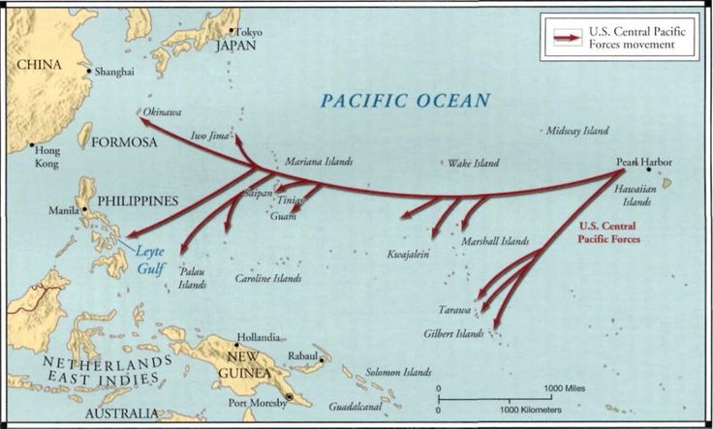

*This map shows the route US soldiers took to “hop” from one island to the next, getting closer to mainland Japan.*

**ALLIED STRATEGIES**

**Island Hopping Strategy in the Asia Pacific**

* The Japanese had dug themselves into island strongholds in the Pacific area.
* To avoid a lengthy and costly campaign against the Japanese, the Allies adopted the island-hopping strategy.
* It involved using air attacks and submarines to attack poorly defended islands held by the Japanese.
* The poorly defended islands will then be conquered by the Allies, and these will be used to further cut off ships that supplied the well-defended islands.
* **THIS WAS A SUCCESSFUL STRATEGY AS IT ALLOWED THE ALLIES TO INCUR FEWER CASUALTIES AND MAKE USE OF RESOURCES EFFICIENTLY AS IT AVOIDED LONG FIGHTS WITH THE JAPANESE. BY CUTTING OFF SUPPLIES TO THE WELL DEFENDED ISLANDS, JAPAN WAS WEAKENED WHICH MADE THEM STRUGGLE TO STOP THE ALLIES. THE ALLIES WERE ABLE TO COME WITHIN STRIKING DISTANCE OF MAINLAND JAPAN.**

**Operation Overlord: D-DAY landings in Normandy**

* 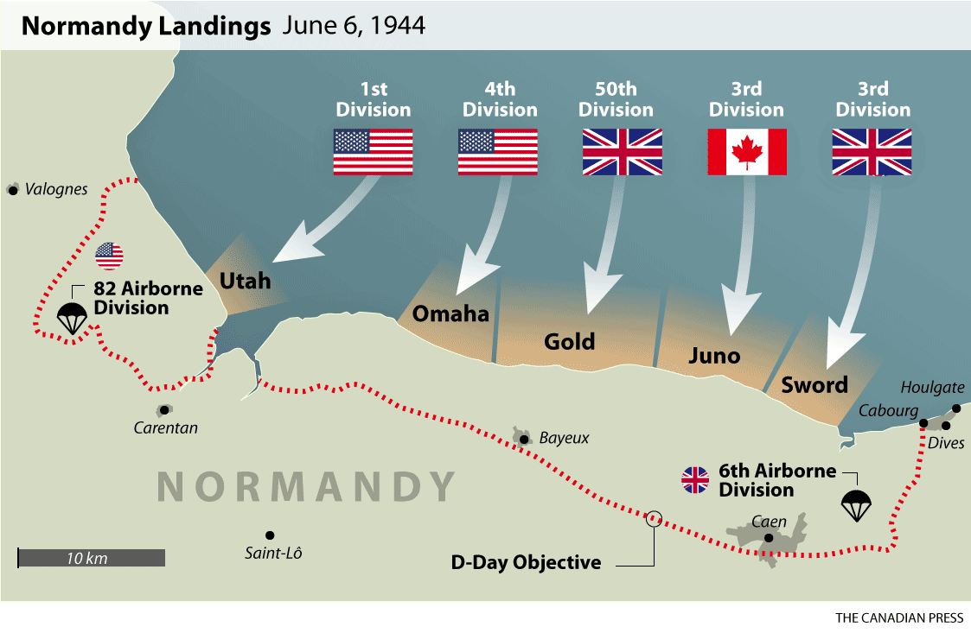Britain was also the staging ground for troops from all over the empire. Especially from Canada and USA.
* This made it possible to conduct the D-Day landings in 1944 and the Allied bombing campaigns against Germany.
* The aim of D-Day was to open a second front against the Nazis, forcing them to split their military from the eastern front to the western front.
* This was a massive Allied operation on 6 June 1944 when combined Allied forces landed on Normandy.
* To liberate France which had been occupied and heavily fortified by the Germans.
* D-Day was successful because of the overwhelming resources, planning and leadership.
* 130,000 Allies troops crossed by sea and 23,000 by air. -> reinforced with tanks, weapons, ammunition.
* 13,000 Allied aircraft bombed radar installations, rail links and bridges -> Germans only had 400 aircraft in Normandy.

This cut off German forces in Normandy from reinforcements.

* **D-DAY WAS SUCCESSFUL BECAUSE IT FORCED GERMANY TO SPLIT ITS MILITARY TO THE WESTERN FRONT. THIS WEAKENED GERMANY AND ALLOWED THE ALLIES TO INFLICT MORE DAMAGE AND MOVE CLOSER TO GERMANY.**
* **D-DAY ENABLED THE ALLIES TO WIN BACK TERRITORIES CAPTURED BY THE GERMANS AND EVENTUALLY LEADING TO THE DEFEAT OF GERMANY.**

**DROPPING OF ATOMIC BOMB**

* Despite the successes of the island-hopping strategy, the Japanese resisted fanatically leading to a large number of Allied losses.
* The Japanese would fight to the death, for example, they would use Kamikaze pilots to crash their planes into Allied ships killing the pilot as well and inflicting massive damage on the Allies.
* Invading mainland Japan would also lead to large numbers of Allied losses.
* To avoid taking on more casualties and to avoid prolonging the war, USA decided to drop two atomic bombs on Japan. – ‘Little Boy’ on Hiroshima and ‘Fat Man’ on Nagasaki.
* Led to huge damages and horrific casualties. Both cities were reduced to ruins -> long term effects such as cancer and radiation disease.
* Hiroshima casualties 135,000 / Nagasaki casualties 64,000.
* **THE DEVASTATATION CAUSED BY THE ATOMIC BOMBS FORCED JAPAN TO SURRENDER. THEY WERE UNABLE TO COUNTER THE POWER OF THE ATOMIC BOMB AND THE EMPEROR BELIEVED IT WAS THE WISE TO STOP FIGHTING TO AVOID ANYMORE CATASTROPHIC LOSSES.**
* **THE DROPPING OF THE ATOMIC BOMB IS SUCCESSFUL IN ENDING THE WAR EARLY WHICH THEN AVOIDED THE NEED FOR A LONG WAR AND AVOIDING MORE LOSSES FOR THE ALLIES.**

**Importance of Britain**

**Battle of Britain**

* During the Battle of Britain in 1940, British Prime Minister Winston Churchill refused to surrender to the Germans.
* Their superior aircraft, the Spitfires and Hurricanes, were able to match the German aircrafts.
* In addition, their factories were able to produce new aircraft quickly to replace losses.
* Use of Radar to detect incoming aircraft gave the British an advantage.
* Fighting over home ground meant less fuel was needed and more spare parts were available for repairs.
* **BRITISH RESISTANCE AGAINST THE GERMANS PREVENTED GERMANY FROM SECURING AN EASY VICTORY OVER BRITAIN. THIS WOULD EVENTUALLY LEAD HITLER TO SHIFT HIS FOCUS TO THE USSR WHICH WOULD OPEN UP A SECOND FRONT. THIS PREVENTED GERMANY FROM CONCENTRATING THEIR EFFORTS ON A SINGLE DFRONT CAUSING THE MILITARY TO WEAKEN.**

In Asia Pacific:

* Britain’s survival was critical in the war against Japan.
* Japan faced more resistance in the Asia Pacific due to the presence of Britain.
* The Japanese fought the armies and navies of Britain, Australia, and New Zealand and around 120,000 African troops from British colonies alongside US troops.
* The British could use 2.5million men and women from India to strengthen its war efforts.
* **This would overwhelm the Japanese who were running low on resources and unable to sustain a long war.**

**Importance of USSR**

**Operation Barbarossa, 1941.**

* 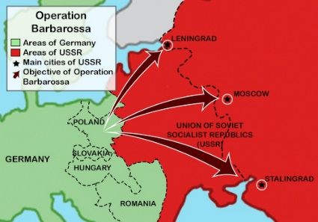Hitler invaded the USSR as he wanted to destroy communism and use the land in USSR for its resources such as oil. -> This is known as the Eastern front.
* Germany was unable to defeat USSR as its harsh winter stopped their advance.
* With support from US Lend lease programme and Stalin’s reorganization of the Soviet war effort -> the USSR were able to put up a strong resistance -> led to high number of deaths within the German army. -> 90% of German deaths in WW2 were in the Eastern Front.
* USSR’s efforts will play an important role in the eventual defeat of Germany.

**HOW DID THE USSR MANAGE TO TURN THE TIDE AGAINST THE GERMANS AND DEFEAT THEM?**

**Reorganization and Resistance**

* 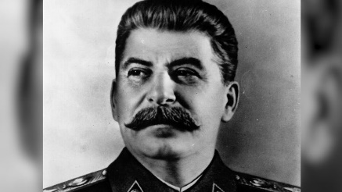Stalin reformed the Red Army during Operation Barbarossa and copied many tactics used by the Germans and added some of his own.
  + New, effective weapons such as T-34 tanks were developed.
  + Harsh Discipline. For e.g. Order 227 “Not a step back” which ordered every soldier to fight and die for every bit of Ussr soil.
  + Tapping into German radio communications and disrupting 2/3 of their comms.
  + Using radio communications in all tanks and aircraft.
  + Freedom for officers in the Red Army to make decisions without interference from the government.
* Inspirational leadership from Stalin who called on his soldiers to defend “Mother USSR” in the “Great Patriotic War”
* Victory during the battle of Stalingrad where USSR soldiers encircled the German army forcing them to surrender.

**THESE REFORMS IMPROVED THE CAPABILITIES OF THE RED ARMY WHICH MADE IT MORE DIFFICULT FOR THE GERMANS TO DEFEAT THEM. THE GERMANS BEGAN EXPERIENCED HIGHER LOSSES FIGHTING THE REORGANIZED RED ARMY. FOR EXAMPLE DURING THE BATTLE OF STALINGRAD AND KURSK, THE SOVIETS WERE ABLE TO DEFEAT THE GERMANS WHICH MARKED THE TURNING POINT IN THE WAR AT THE EASTERN FRONT. THIS RAISED THE MORALE OF USSR SOLDIERS AS THEY BEGAN TO COUNTER-ATTACK AND DRIVE THE GERMANS BACK INFLICTING HEAVY LOSSES ON THE GERMANS.**

Battle of Stalingrad

* The Soviets were able to resist the Germans fiercely inflicting heavy losses on them. They managed to defeat the German army which was a huge blow to the Germans as it severely weakened their war efforts.

Battle of Kursk.

* USSR’s strength was seen at the Battle of Kursk where the USSR had 10 times more tanks, more aircraft, artillery and thus achieved victory in this battle.
* The Soviets began moving towards Germany in a massive counterattack and eventually reaching Berlin in May 1945 leading to the defeat of Germany.

**Resources and Production: The Soviet War economy**

* Harsh methods were implemented to ensure the Soviet economy could keep up with the demands of the war.
* Adults received no food unless they worked and contributed to the war effort.
* Forced labour was used and the secret police kept close watch over the population.
* This was very effective as Soviet production rate increased and surpassed Germanys.
* They produced a small range of weapons but in great quantities. -> Produced 1.5 times more aircraft and 2 times more tanks than the Germans by 1943.
* Shifted their major industrial areas to the Urals, Siberia, and Kazakhstan -> 25 million workers were forced to migrate east which would later contribute to the increase in war production in the USSR.

Allied support from Britain and France further strengthened the USSR.

* Supplied vast amounts of food, raw materials, and industrial equipment via shipping routes.
* USA supplied 500,000 motor vehicles and 1900 locomotives and half of its supply of rubber tires and copper.

**This was very effective as soviet production rate increased and surpassed germanys. This would give the ussr an advantage over the germans when they faced each other in battle as the ussr would have more weapons and soldiers. They were able to outlast the germans in a long war. This gave an advantage over the germans as the ussr were able to overwhelm them with numerical superiority and inflict heavy losses on the germans.**

**In the Pacific Theatre**

* USSR declared war on Japan on 8th August 1945 and launched a three-front invasion on Manchuria.
* Defeated the Kwantung army in Manchuria, occupied Northern Korea
* Weakened Japan.
* This contributed to Japan’s surrender to the Allied forces.

|  |
| --- |
| **WEAKNESSES OF THE AXIS POWERS** |

**Germany’s military weaknesses – Ineffective command structure**

* German commanders had to constantly report to Hitler who intervened in military decisions. This inefficient command structure led to many critical mistakes being made
* Hitler had little military command experience and lacked experience and was ill-qualified to make high level military decisions.
* He did not trust his military commanders and often overruled their decisions because of his need to appear in charge. His decisions were often based on pride rather than logic-> this led to many incorrect decisions being made which were costly for the German army.
  + For example, he went against his Generals’ wishes and ordered his army to halt instead of encircling the retreating Allied forces at Dunkirk. This mistake allowed hundreds of thousands of Allied soldiers to escape to Britain and return to fight another day.
  + Another example of a mistake was at the Battle of Stalingrad. His commanders wanted to withdraw as they met stubborn resistance from Soviet troops. However, Hitler overruled them and demanded they take over Stalingrad as it was a matter of pride for him to take control of a city that was named after Stalin. He committed hundreds of thousands of soldiers to a pointless battle which they eventually lost in 1943. Many thousands of German soldiers died, and many taken prisoner.
  + In addition, he declared war on USA after the Pearl Harbour attack despite having no reason to. This brought USA and its massive resources and military might into the European theatre. This would strengthen the Allies significantly and overwhelm Germany. Germany would suffer huge losses and eventually lead to its defeat.
  + **THE INNEFFECTIVE COMMAND STRUCTURE CONTRIBUTED TO GERMANY’S DEFEAT BECAUSE HITLER WOULD OFTEN GO AGAINST HIS COMMANDERS’ DECISIONS AND MAKE SERIOUS ERRORS WHICH WEAKENED GERMANY’S WAR EFFORTS.**

**WAR ON TWO FRONTS**

* When Hitler failed to defeat Britain, he opened a second front in the East by invading the USSR in Operation Barbarossa.
* **THIS WAS A MISTAKE BECAUSE PREVENTED HIM FROM CONCENTRATING HIS EFFORTS AND RESOURCES ON A SINGLE FRONT WHICH WEAKENED GERMANY’S MILITARY. IT WILL DRAIN GERMANY OF RESOURCES AS THEY HAD TO FOCUS THEIR WAR EFFORTS ON TWO FRONTS. THIS MADE THEM VULNERABLE TO ALLIED ATTACKS SUCH AS THE BOMBING OF GERMAN CITIES. THIS WILL EVENTUALLY LEAD TO GERMANY’S DEFEAT.**

**POOR PLANNING**

* Germany did not build aircraft carriers – instead focusing on large battleships. Battleships were easily destroyed by the Allied aircrafts.
* Germany did not build heavy bombers like how USA and Britain did. The US and Britain relentlessly bombed German cities from 1942 to 1945 causing significant damage. However, Germany was unable to do so as their bombers were too small and could not carry enough bombs.
* Germany did not build their own radars which put them at a disadvantage. They also lacked fuel, ammunition, and spare parts.
* **POOR PLANNING WEAKENED THE GERMAN MILITARY WHICH EVENTUALLY LED TO THEIR DEFEAT AS THEY WERE UNABLE TO RESIST THE ALLIED FORCES WHO WERE CLOSING IN ON GERMANY.**

**Japan’s military weaknesses**

**Inter Service rivalry between army and navy.**

* Long term conflict between army and navy who had different goals and ideas on how to obtain resources and conquer countries to sustain Japan’s economy.
* They refused to share resources, military intelligence and coordinate their attacks and defenses against the allies.
* For e.g. when the navy asked for support in its invasion of Australia, the army refused. And was unresponsive throughout the war -> they refused to commit major reinforcements to the Pacific and were late to see the threat posed by USA.
* **THE LACK OF COOPERATION WOULD WEAKEN THE JAPANESE WAR EFFORTS AS THEY WILL BE OVERWHELEMED BY THE MORE COORDINATED AND EFFICIENT ALLIED FORCES.**

**Overstretched Empire**

* The empire was spread out over a large area. Despite the large empire, the Japanese were unable to utilize the resources from the territories efficiently.
* Difficult to deliver raw materials and workers efficiently to the places they were needed due to poor rail and road networks.
* Large quantities of raw materials and finished goods such as weapons and vehicles had to be transported by sea which was more difficult and inefficient.
* **THIS WOULD WEAKEN THE JAPANESE MILITARY AS THEY WILL BE UNABLE TO RECEIVE THEIR RESOURCES NEEDED TO SUSTAIN THE WAR EFFORTS. IT WILL BE DIFFICULT TO DEFEND THEIR LARGE EMPIRE WITH LIMITED RESOURCES AND THIS WILL CONTRIBUTE TO THEIR DEFEAT.**

**POOR PLANNING**

* Japan did not see the importance of aircraft carriers -> Failed to destroy US aircraft carriers at Pearl Harbor (see next page) -> this meant US navy could recover quickly from the attack and retaliate against Japan.
* Japan focused on building battleships and thus lost the advantage they could have had if they had focused on aircraft carriers and training more navy pilots.
* Did not focus on anti-submarine methods -> This allowed Allied submarines to destroy many Japanese trading ships.
* **THIS MEANT THE JAPANESE DID NOT HAVE CONTROL OVER THE SEAS IN THE PACIFIC. IT BECAME DIFFICULT FOR THEM TO TRANSPORT RESOURCES FROM THEIR EMPIRE TO THE MAINLAND TO SUSTAIN THEIR WAR EFFORTS AS MERCHANT SHIPS WOULD OFTEN BE SUNK BY ALLIED FORCES. THIS WEAKENED THE JAPANESE MILITARY.**
* Harsh treatment of locals in their empire made the them resent the Japanese.
* Millions of civilians died under Japanese rule -> People in these conquered lands began to resist the Japanese .
* For e.g. large scale resistance movements and guerrilla campaigns were conducted in China, Korea, Vietnam and Maaya to stop the Japanese make use of the resources in the empire.
* **THIS MEANT THE JAPANESE MILITARY WAS DRAINED OF RESOURCES TRYING TO PUT DOWN THESE RESISTANCE MOVEMENTS. THEY WERE UNABLE TO SUSTAIN THEIR WAR EFFORTS EFFICIENTLY DUE TO A LACK OF RESOURCES COMING IN FROM THEIR EMPIRE. THIS WEAKENED THE JAPANESE MILITARY.**

KEY DEVELOPMENTS IN ASIA-PACIFIC: 1937-1945

**Attack on Pearl Harbor**

* In 1941 Japan attacked Pearl Harbor.
* USA lost 2000 sailors and 18 ships.
* The surprise attack outraged USA and united the country against Japan.
* USA declared war on Japan and directed its huge resources towards war.
* USA was able to recover quickly in a few months and retaliate.
* USA built new warships and superior carrier based aircraft such as the Douglas Dauntless dive bomber.
* Japan made a huge error in not destroying US aircraft carriers during its attack on Pearl Harbor.
* This allowed the USA to continue to using them during the war and prevent Japan from controlling the Pacific Ocean -> this will contribute to Japan’s eventual defeat.

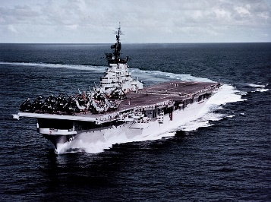**Battle of Midway, 1942**

* Decisive battle where Japan lost 4 aircraft carriers and ¾ of their experienced pilots – weakening their naval and air defence capabilities for the rest of the war.
* In addition, Japan was overwhelmed by the superior production capabilities of US shipyards and aircraft factories.